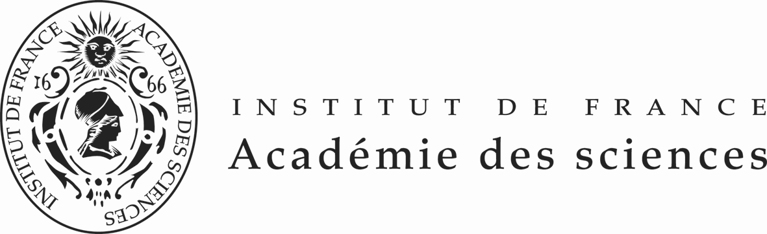

FONDATION FRANCO-CHINOISE POUR LA SCIENCE ET SES APPLICATIONS (FFCSA)
POST-DOCTORAL FELLOWSHIPS OFFERED

PROMOTION 2016
(18 months or 24 months and exceptionally 36 months)

2nd Call for candidates: January 1st, 2016

FFCSA’s Fellowships are awarded for 18 months or 24 months and exceptionally 36 months.
They are exclusively aimed at candidates living in mainland China who wish to come to France. Chinese scholarship holders currently in France who are seeking to extend their stay are not eligible to apply.

Fellowships offered are aimed exclusively at post-doctoral scholars, who have obtained their Ph.D. before June 2016 and within the last 6 years and are under 40 years of age. A fluent knowledge of English is a pre-requisite for admission.

Selection of candidates is a three-stage process:

- call of offers, and short-listing of candidates in China, under the guidance of China Scholarship Council (CSC) and the Chinese Academy of Sciences (CAS) .

- interviews in China, in Beijing and Shanghai, by an FFCSA expert panel from France (candidates’ travel costs to the interview locations are at the candidates’ expense).

- Final decision in France by the FFCSA’s Scientific Council on the candidates selected and on their host laboratories in France, with the confirmation of CSC and the CAS.

The timetable for the second call of offers promotion 2016 award is as follows:

  - January 1st , 2016: Call of proposal publication in French, English and Chinese of the Fellowships offered for promotion 2016.

March 31st , 2016: deadline for applications in China and in France.

  - From April 4th till April 8th ,2016: interviews of short-listed candidates in Beijing or Shanghai by examinators send by the FFCSA; ranking of candidates for each fellowship offered.

  - April 29th ,2016: final decision on candidates selected by the FFCSA’s Scientific Council, with the confirmation of CSC and the CAS; candidates selected will be immediately informed and will be required to start learning French before leaving China (stage in charge of the CSC).

  - May-June , 2016: One month French language and Culture initiation in China.

  - September , 2016 arrival in France of candidates selected.

The international plane fare from China to France and return is taken in charge by the CSC. The travel cost to provincial France when necessary will be covered by the FFCSA. The total amount of the fellowship is € 2 500 net per month. The cost of health insurance is covered by the FFCSA.

Whichever the date corresponding at research work during the fellowship, publications should mention imperatively the help of the FFCSA and CSC.

During his/her stay in France, each scholar will be counselled by the FFCSA whose task is to ensure the harmonious integration of the scholar and the smooth development of his/her research programme. The scholar’s return to China is mandatory. FFCSA had created an Alumni Club in January 2005.

For the class 2016, 18 months or 24 months, and exceptionally 36 months beginning September 2016, 15 fellowships offered are in the following subjects in the laboratories selected by the FFCSA:

- Control of pancreatic beta cell development in rodent and human

- Immunological properties of mesenchymal stem cells and their applications in transplantation and regenerative medicine.

- Reactivity of high capacity negative electrode materials used in lithium-ion batteries

- Dissection of molecular mechanisms controlling tissue formation in rice roots

- Stem Cells and root development

- Root tissue –specific transcriptomic and system biology

- Development and applications of bioinformatics tools for Next-Generation Sequencing (NGS) data

- A causal relationship between tumor cells and platelets: The role of platelet integrins β₁ in metastatic dissemination?

- Protein degradation induced by drugs

- High Precision Inertial Sensors based on Atom Interferometry

- Atom interferometry and Bloch Oscillations in optical lattice :application to high precision measurements.

- Macular dystrophy of the retina named EMAP foe Extended Macular Atrophy with Pseudodrusen. Analyse of the EMAP exomes and additional sequencing analysis to confirm the linkage of sequencing variants with the pathology

- New therapeutic strategies for immunotargeting .Non-Hodgkin Lymphomas

- Slowing of molecules by temporary Rydberg electron capture

- Design of Hybrid Nanoporous Materials with high proton conduction

- High –resolution spectrometry of H2+

- Pancreatic beta cells : Dissecting signals controlling beta cell development and function

- Innate Immunity –Inflammation: regulation of Caspase -11 and host defense to Gram negative enteric bacterial pathogen.

IMPORTANT
If the applicant chooses 2 thematics, he /she has to give his/her preference whether A or B
Candidates application’s package should include (see the application form):
-a detailed CV,
-a motivation letter pointing out either the suitability of your CV,
-the scientific publications,
-the research grants,
-and two letters one from the head of the laboratory and one from the President of their University or from a Science Academician if he or she is not working in a University.

Candidates should send their application package by e-mail at all the following address ffcsa@academie-sciences.fr

The deadline is March 31st, 2016

If the candidate is selected after the interview , he/she will have to apply on the CSC Website.Mme ZHANG Ying, Project Officer, Division of Cooperation and Consultancy, China Scholarship Council,9-A3 Chegongzhuang street Beijing 100044, P.R.China , e mail : yzhang@csc.edu.cn .

The FFCSA will inform the China Scholarship Council and the Chinese Academy of Sciences of the progress timely.
URL http://www.academie-sciences.fr/activite/inter.htm and http://www.ffcsa-club.org/fr/newscenter.html

